IoT – Arduino based Fingerprint Attendance System
System Requirements Specification

Revision History
Date (dd/mm/yyyy) | Version | Description | Author
(01/05/) | 1.0 | In today's fast-paced world, efficient management of attendance systems is crucial for organizations of all sizes. Traditional methods of attendance tracking, such as manual registers or swipe cards, are prone to errors and can be easily manipulated. To address these challenges, the integration of Internet of Things (IoT) technology with biometric authentication offers a promising solution.  The IoT-Based Arduino Fingerprint Attendance System is a project designed to provide a robust, secure, and automated attendance management solution using Arduino microcontroller technology and fingerprint recognition. By leveraging the power of IoT, this system offers real-time monitoring, remote accessibility, and scalability, making it suitable for various environments such as schools, offices, and industrial settings. | AFREEN ANWAR

Table of Contents

- Scope (of the project)
- Functional Requirements Non Functional requirements
- Project Proposed Design (Block Diagrams)
- Project Flow (Flow Charts)
- Adopted Methodology
- Work Plan (Use MS Project to create a Schedule/Work Plan)

- Scope of Project:

This project presents a simple and portable way to student attendance by the use Internet of Things (IOT) based system that records the attendance using fingerprint based biometric scanner and stores them securely over cloud. The idea of this project was taken to overcome all the issues in all previous technologies and make data in digital way. Attendance is a concept that exists in different places like institutions, organizations, hospitals, etc. In morning and evening to mark a person’s presence. Since the past, the traditional way of taking attendance in a class includes a pen, attendance book or registers and a person. Thus the drawbacks arise as it consumes time, needs manual work and the most important, information or the attendance can be manipulated. Also, there are chances of students not responding to their attendance and later claiming for the attendance. The new procedure of taking attendance using IOT is easier and therefore overcomes all the above mentioned drawbacks. Apart from this, forging a signature in an attendance sheet may also happen. The work in-creases much more if the class strength is more. Hence, a lot of work and time and force has to be put into attendance verification and analysis. In any IOT based system, the hardware consists of sensors, microcontroller, display, and the most important, hardware providing access to the internet. The Fingerprint technology serves as an identity proof to take the attendance of students. This project uses the concept of Internet of Things to set up a smart attendance tracking system

- Functional and non Functional Requirements:

1 . User Enrollment:
- Users should be able to enroll their fingerprints into the system for identification.
2 . Web/User Interface:
- Provide a user-friendly interface, possibly through an LCD display, for interaction with the system.
3 . Real-Time Monitoring:
- Provide real-time updates of attendance status to administrators.
- Display attendance logs and summaries for monitoring and reporting purposes.
4 . Database Management:
- Store attendance records securely in a database.
- Support efficient retrieval and querying of attendance data.
- Generate reports
5 . Error Handling:
- Detect and handle errors gracefully, providing informative feedback to users in case of authentication failures or system malfunctions.
6 . Remote Accessibility with Web:
- Allow authorized personnel to access attendance data remotely via internet connectivity.
- Enable remote management and configuration of the system.
Non-Functional Requirements:

1. Security:
Ensure the security and integrity of biometric data stored in the system.
2. Reliability:
The system should operate reliably under normal conditions, with minimal downtime
3. Performance:
Achieve fast and responsive fingerprint authentication within acceptable response times.
4. Usability:
Design an responsive and easy-to-use interface for both admin and end-users.
5. Compatibility:
Support connectivity options such as Ethernet and Wi-Fi for seamless integration into different environments.

- Project Proposed Design / Block Diagram(s):

Arduino-based Fingerprint Attendance System is an exciting project!
Here's a proposed block diagram:
Overview:
The system will consist of several components:
fingerprint sensor module,
an NodeMCU microcontroller,
a display module (like an LCD),
a database system for storing attendance records.

CPU
ESP8266

FINGERPRINT
SENSOR
LCD

WEB
SERVER

Net
POWER SUPPLY
Wifi
PC-1
PC-2
PC-3

Components:

1.Fingerprint Sensor Module: This module captures fingerprints and converts them into digital data for comparison.

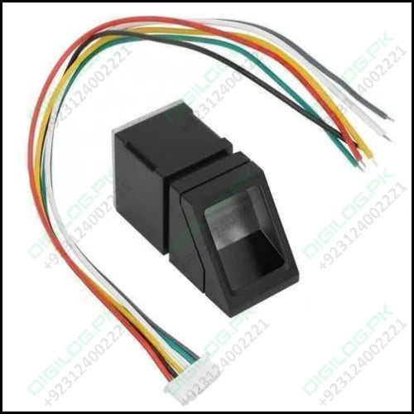

2.Node MCU (e.g., esp8266): Acts as the main processing unit, interfacing between the fingerprint sensor, display, and database.

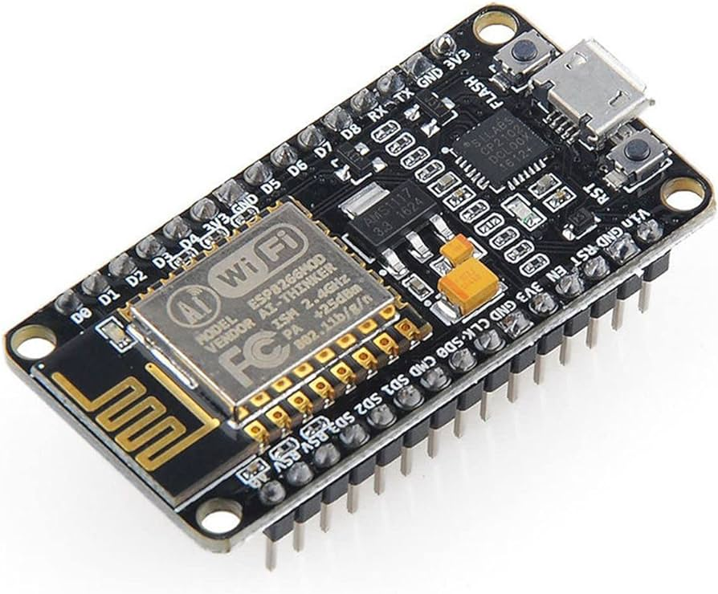
3.Display Module: An LCD or OLED display to show system status and attendance information.
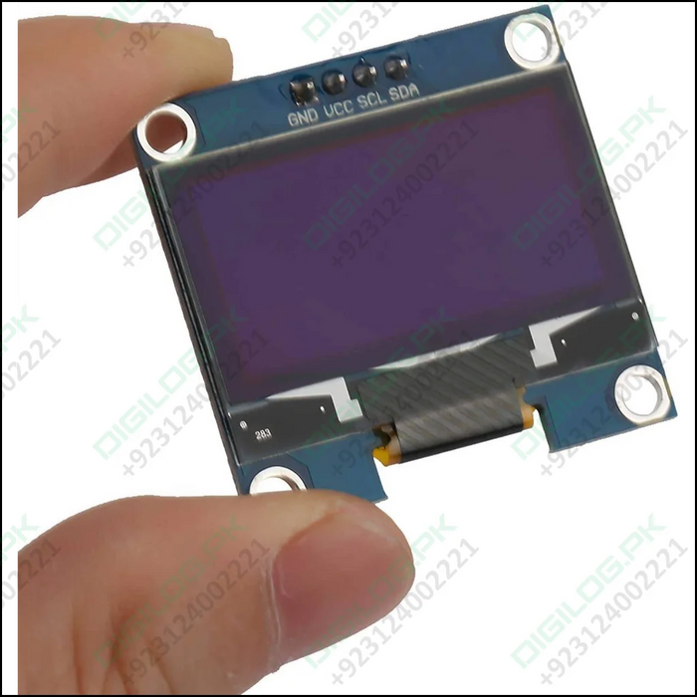

4.Database System: Could be an external storage like online database for storing attendance records.

5.Power Supply: Ensure a stable power supply for all components.

- Flow Chart:

START

READ SIGNAL FROM SENDOR

SCANING AND MATCHING

False
Check for match if
Show Not Valid on LCD

True
Display ID on LCD

Store data in memory and cloud where admin can exess

END

- Adopted Methodology

The following Adopted methodology.To implement the Arduino-based Fingerprint Attendance System:

1. Requirements Analysis:
Define the functional and non-functional requirements of the system.
dentify key features such as enrollment, authentication, data storage, and user interface.

2. System Design:
Design the system architecture, including hardware and software components.
Specify the interaction between components, data flow, and interfaces.

3. Component Selection:
Fingerprint sensor module compatible with Node MCU.
NodeMCU (esp8266) microcontroller board.
Display module (e.g., LCD or OLED display)
External storage for database (e.g., Cloud
Power Supply

4. Software Development:
Develop firmware for NodeMCU (esp8266) using the Arduino IDE
Write code to:
Initialize hardware components.
Implement enrollment and authentication algorithms.
Manage data storage and retrieval.
Handle user interface interactions.

5. Integration and Testing:
Integrate hardware and software components to build the complete system.
Conduct unit tests to verify the functionality of individual components.
Perform integration tests to ensure proper communication and interaction between components.
Conduct system tests to validate the overall system behavior against requirements.

- Work Plan:

Creating a Gantt chart for a project like the Arduino-based Fingerprint Attendance System can help in visualize the timeline of tasks and their dependencies.

This Gantt chart provides a timeline for each major phase of the project, including start dates, end dates, and durations. Tasks such as requirements analysis, system design, software development, and deployment are broken down into specific time frames, allowing for better project management and tracking of progress.

